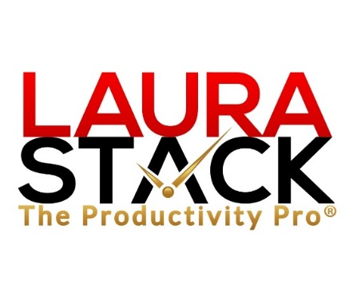

About Laura Stack, MBA, CSP, CPAE

Laura Stack, MBA, CSP, CPAE, is best known by her moniker “The Productivity Pro®.” Stack is an award-winning keynote speaker, bestselling author, and noted authority on employee and team productivity. She is the President & CEO of The Productivity Pro, Inc., a boutique consulting firm dedicated to helping leaders increase workplace performance in high-stress environments. Stack was the 2011-2012 President of the National Speakers Association.

For over 25 years, Laura Stack’s keynote speeches and seminars have helped associations and Fortune 1000 corporations improve output, increase speed in execution, and save time in the office. She is a high-energy, high-content speaker, who educates, entertains, and motivates professionals to deliver bottom-line results. Stack is a member of the prestigious CPAE Speaker Hall of Fame, which has fewer than 200 members worldwide), and has earned the Certified Speaking Professional (CSP) designation.

Laura Stack is the bestselling author of seven books published by Random House, Wiley, and Berrett-Koehler, including her newest, Doing the Right Things Right: How the Effective Executive Spends Time (Jan. 2016). Her books have been published in more than 20 foreign editions, and she is a featured columnist for the American Business Journal, LinkedIn, Time Management, and Productive magazines. Stack has produced more than 50 online training programs.

Laura Stack has been featured nationally on the CBS Early Show, CNN, NPR, Bloomberg, the New York Times, USA Today, the Wall Street Journal, Entrepreneur, and Forbes magazine. Stack has been a spokesperson for Fellowes, Microsoft, 3M, Skillsoft, Office Depot, Day-Timer, and Xerox. Her client list includes top Fortune 500 companies, including Starbucks, Wal-Mart, Aramark, Bank of America, GM, Wells Fargo, and Time Warner, plus government agencies such as the Internal Revenue Service, the United States Air Force Academy, the Census Bureau, the U.S. Senate, and the Department of Defense.

Laura Stack lives with her husband and three children in Denver, Colorado.

